

**ICT K3 Students’ assignment for 10 Most Wanted**

The Museum of Design in Plastics needs your help to track down information about these objects.

The assignment will increase your understanding of the internet as a research tool and enable you to participate in a national project.

If you find a ‘wanted’ fact it will be added to the Museum’s record of the object and, as long as you give your permission, you will be credited as the researcher who found it out in perpetuity.

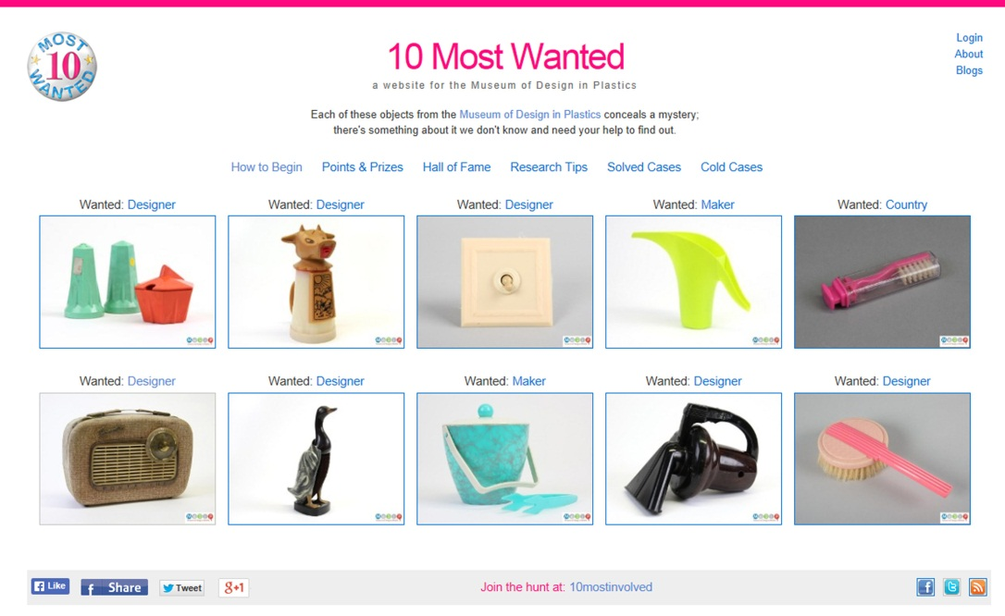

***What is the task?***

The task is to select an object from the 10 Most Wanted website that interests you and use the internet to find out more about it. However more important than what you find out are:

* the processes you go through,
* the way you record what you do
* the extent to which you reflect on what you experience.

***How do I get started?***

While in the classroom please:

* Go to [www.10most.org.uk](http://www.10most.org.uk) and click on an image of an object that you would like to research.
* Read what it says about the object.
* Note down any information you would like to contribute to the record including its specific ‘wanted’ information.

***What do I do next?***

Now, either in class or as homework, you need to see what you can find out. Do this by:

* Entering keywords relating to the object and what you want to find out into a search engine.
* Use contents list and indexes to help you ascertain whether websites you access have the kind of information you are looking for.
* Consider whether you think the information may be presented in a biased way or if you think it is trustworthy.
* Keep a record of the address of the three most relevant websites that you find and note down:
  + Why they are relevant
  + The differences and similarities between them.
  + Who / what has provided the information. You will often find yourselves looking at company/organisation websites rather than websites originated by a single individual.
  + Why you trust them.
* Keep a record of one website that features your object that you have not found helpful and note down:
  + Why it was not helpful.
  + How you would catagorise it as a website, e.g. personal blog, company website, museum website.

***How do I share what I have done?***

Write a brief presentation (your teacher will tell you how long it is to be) that you can give in class, covering:

* Interesting information you have discovered.
* Who originated your three most relevant websites and what was good about them.
* An example of a website that was misleading or unhelpful and why.
* How the assignment has affected or not your relationship with the internet.

**The Museum of Design in Plastics would like to feature your presentation on its website:** [**www.modip.ac.uk**](http://www.modip.ac.uk)**. If you would like that, please ask your teacher to send it to modip @aub.ac.uk, and let us know if you would like to receive one of the 10 Most Wanted badges.**

         